1.Only badges shown. Add stickers and magnets too
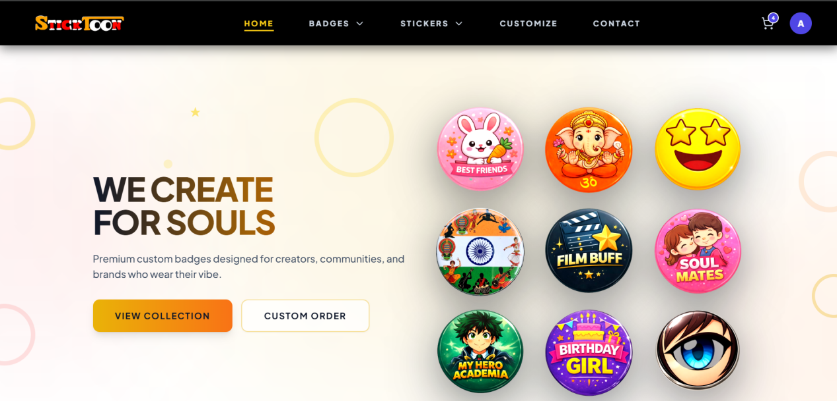
2.Clicking on a badge from home page should redirect to that specific badge. Show it with priority, if not available show out of stock.
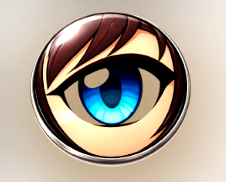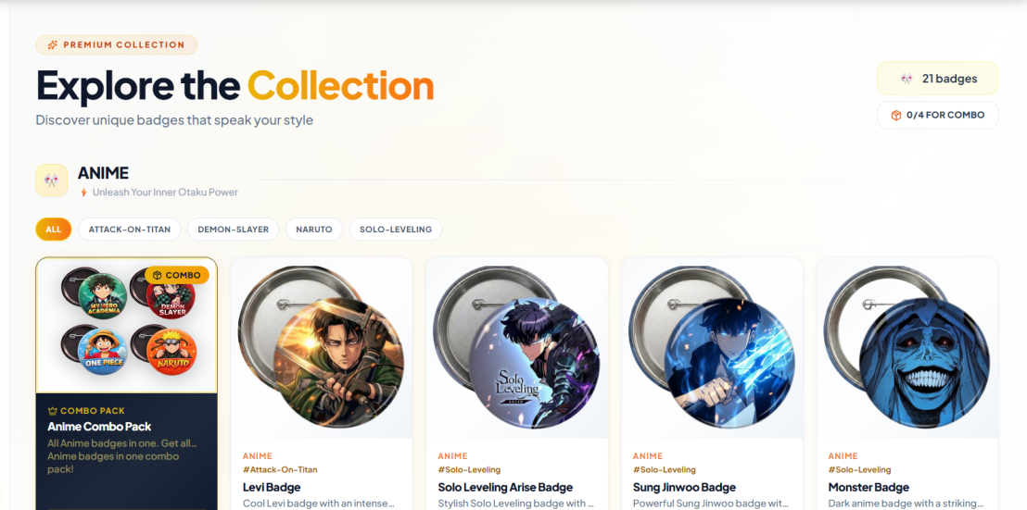
3.Adding to cart shows no difference. How do I know what I have added in cart without going to and fro to cart every time.

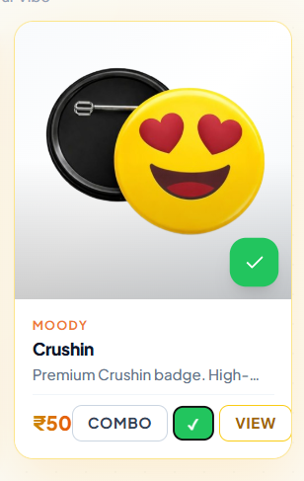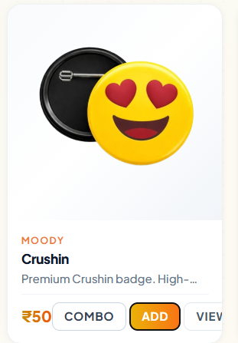
4.Scrolling issues mant places.
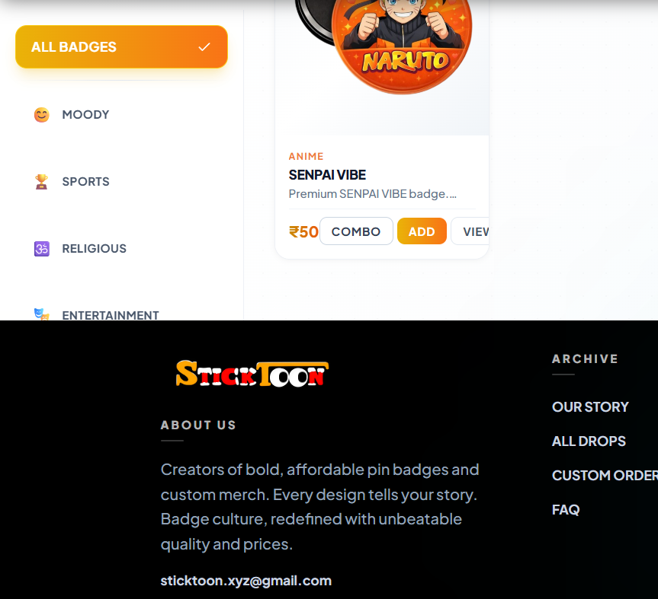
4.If I scroll on dashboard, the right side badges should not scroll up
5.Pin and magnet not differentiated properly. Customer wont know which has been selected.

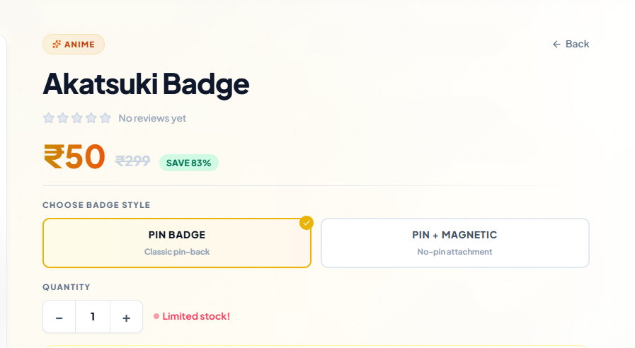
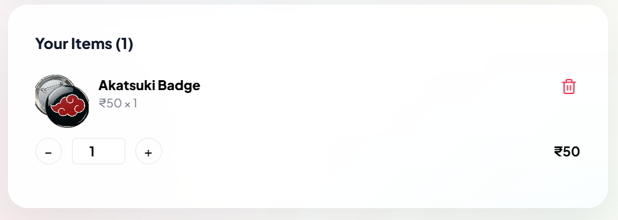
6.Clicking on place order from insta page directly places an order I insta chat.
7.Make a bot to ask if you want to place an order, how many quantity. Better to just redirect to website to that specific product rather than to open dm.
8.Keep dm for questions and inquiries not to place order. (how will insta dm orders be tracked?)
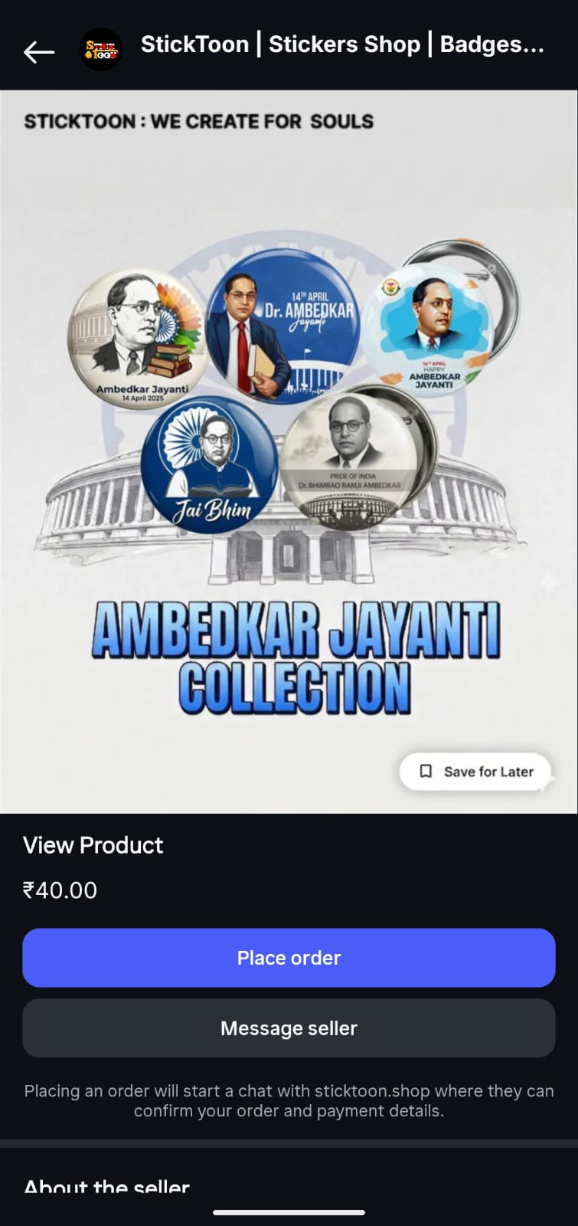
9.Stickers are not clickable. No description of length width quantity provided.
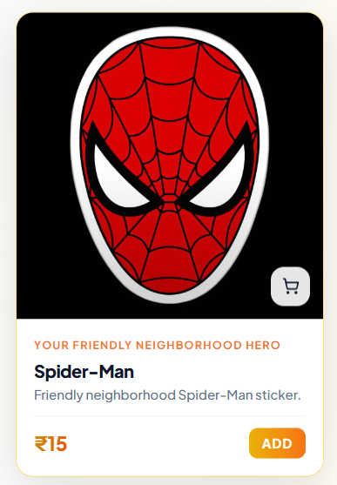
10.Custom orders difficult to customize on mobile. Takes up entire screen to know whats happening behind. Remove that zoom rotate option for mobile instead keep touch enabled editing.
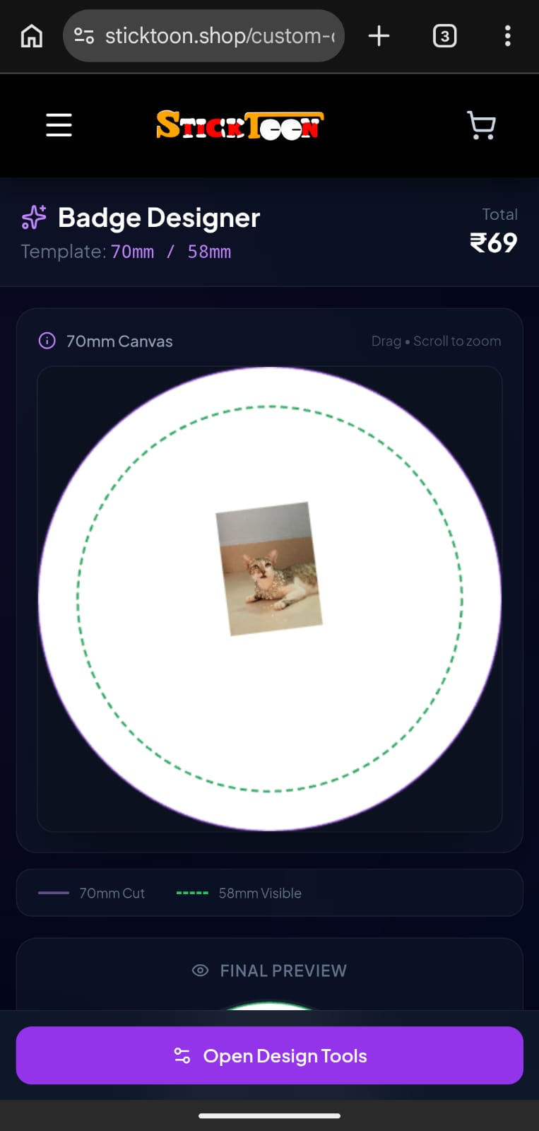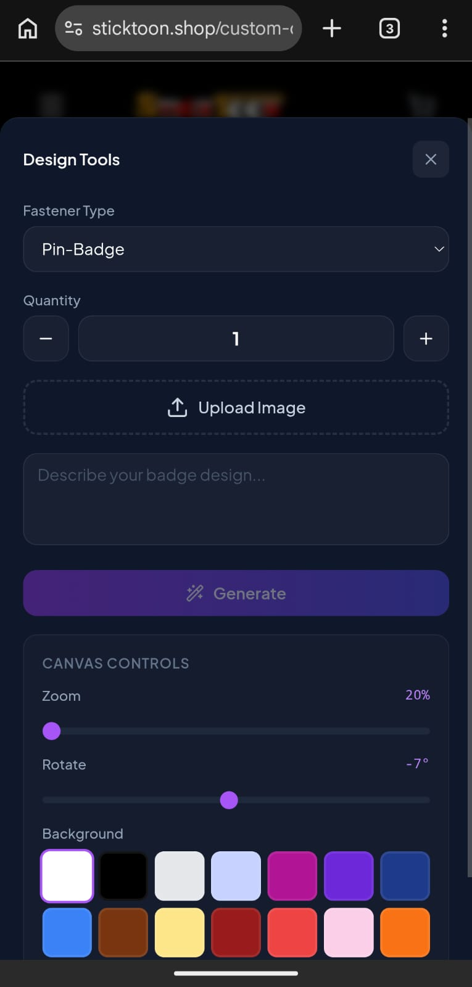
11.Why save for later on posts?
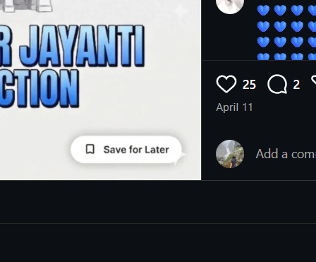
12.
13.If not clickable then why it pops up on hover? 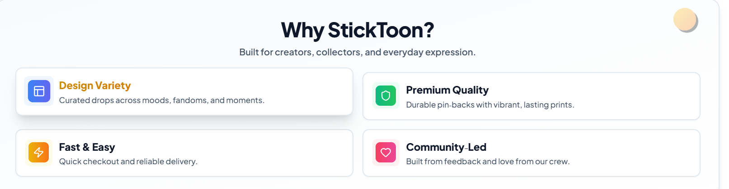
14.Even when I logged out my custom image is still there
15.No option to delete this image
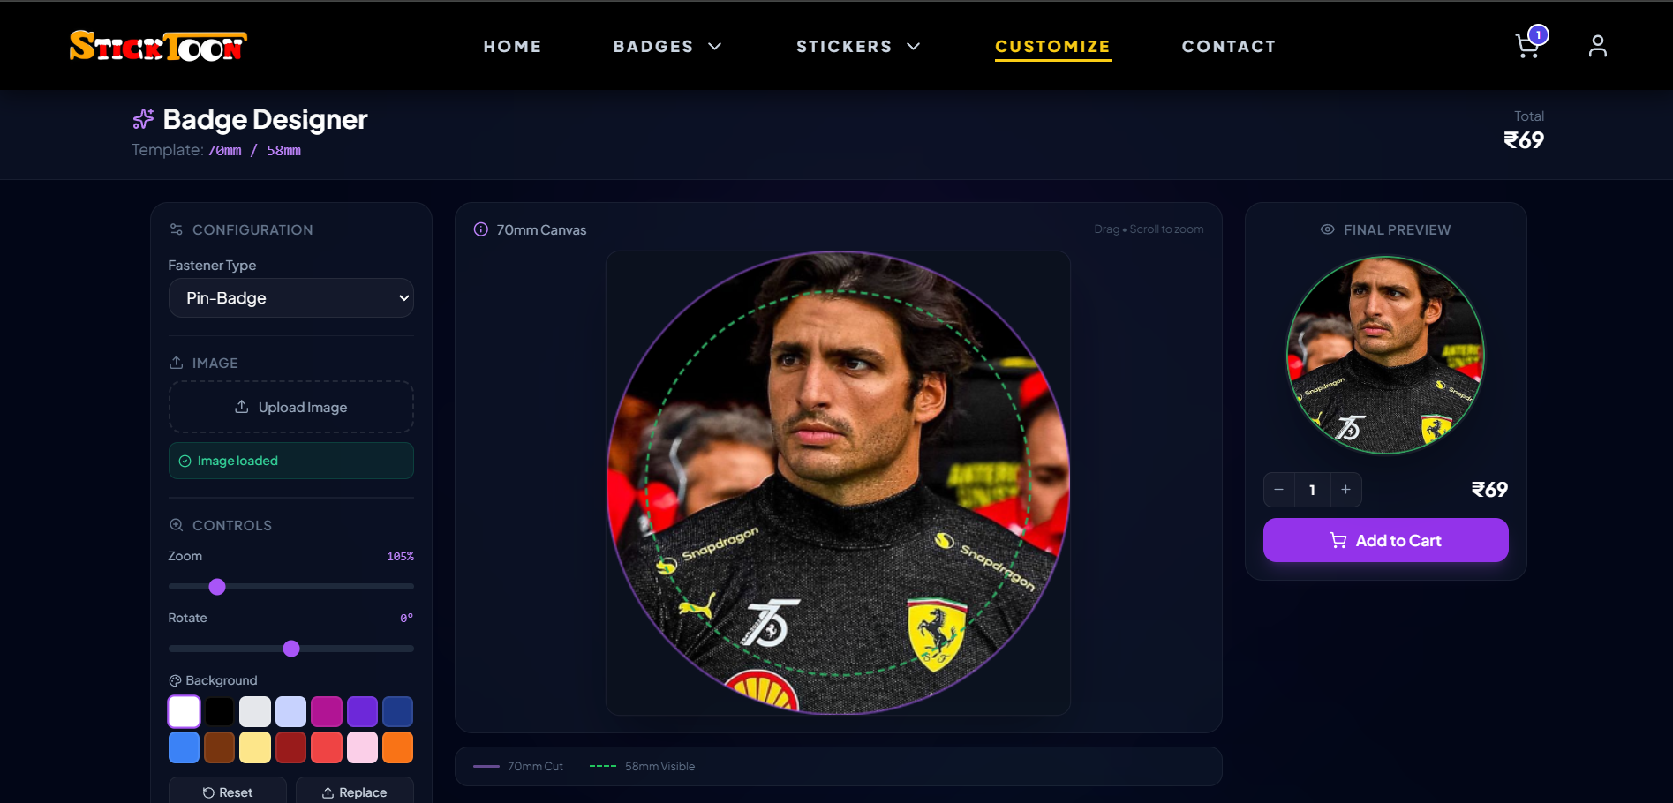
16.Soul’s? it should be souls

17.Even if I unsend the message the was sent after clicking place order, it still shows waiting for confirmation.
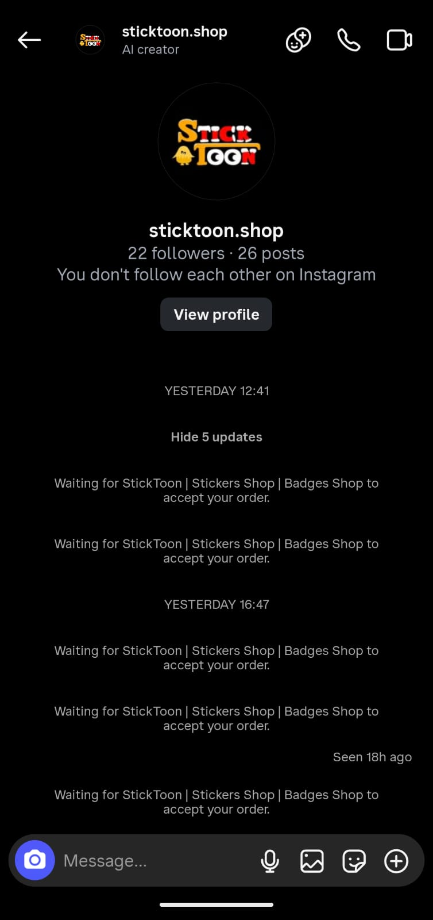
18.Add fridge magnets option

- Clicking on fridge magnets opens badges 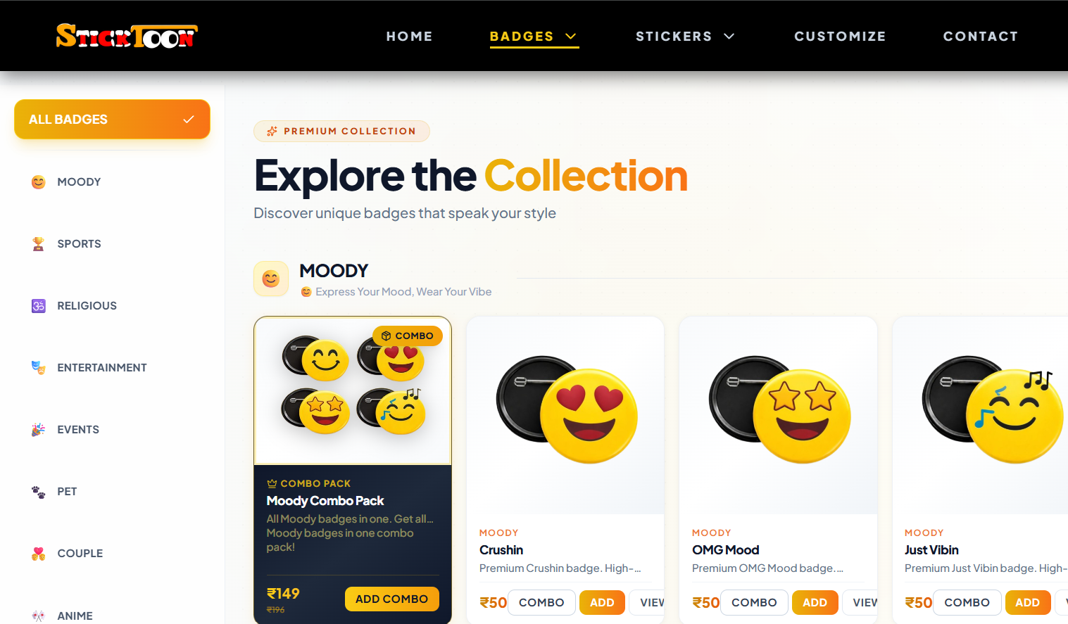
20.How many sticker? Size width??
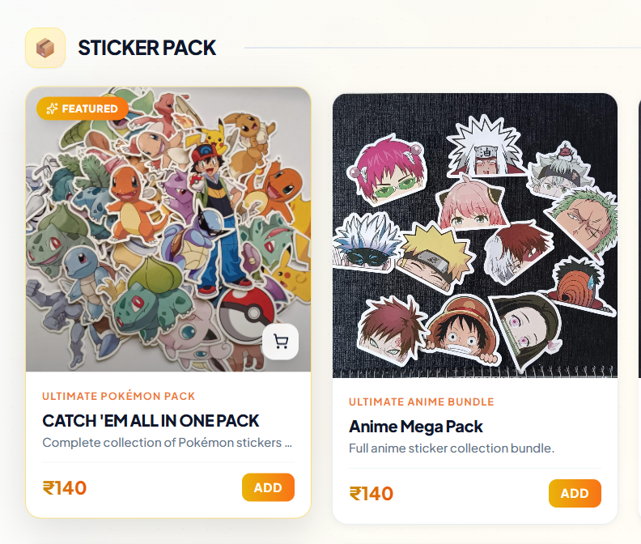
21.Bunch price same as single price??

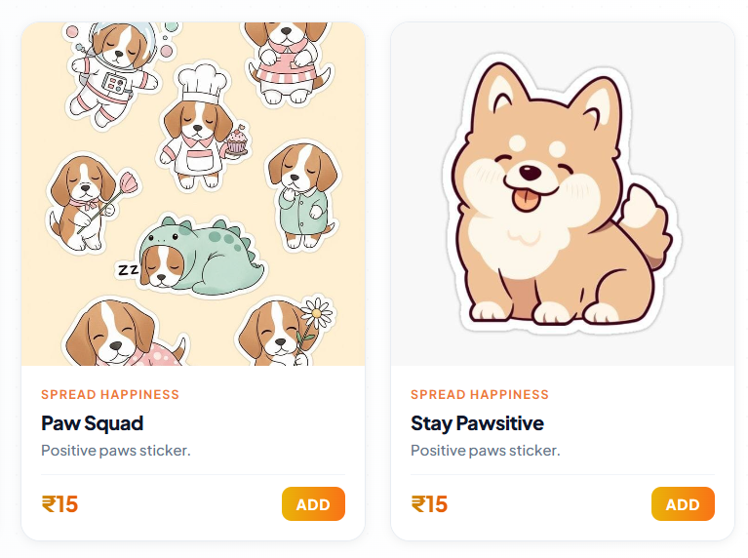
22.Edit products obstructs upper section
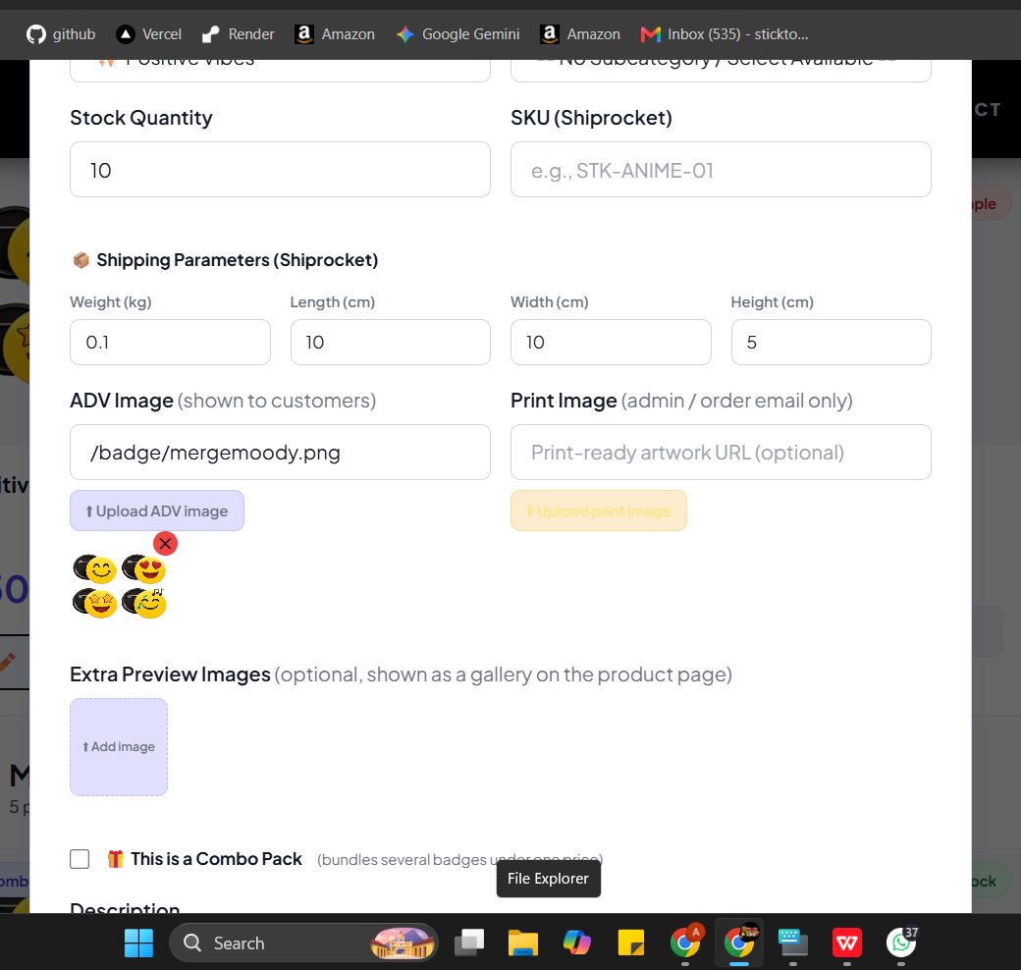

23.Add collapse option and search bar
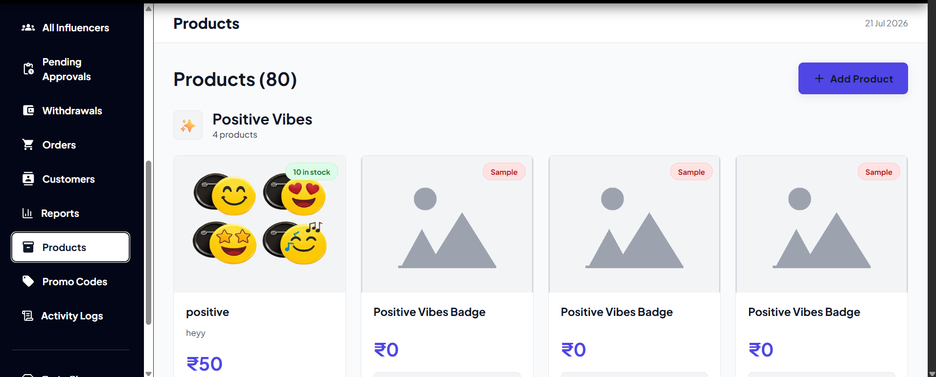
24. Different dashboard in some places?
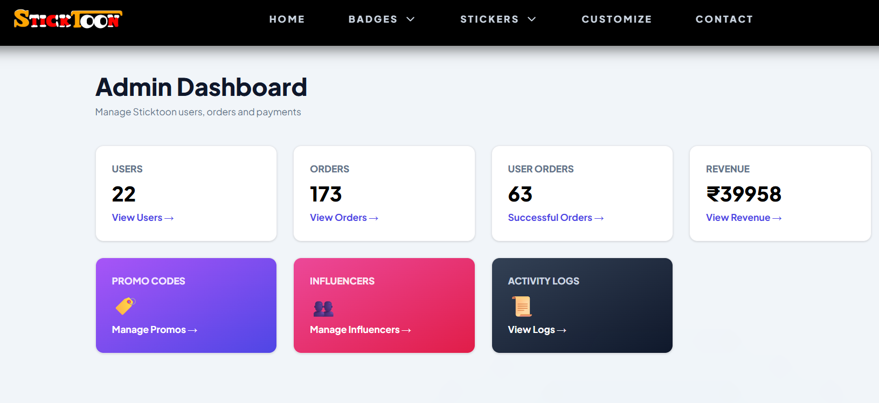
25.Different UI at different places
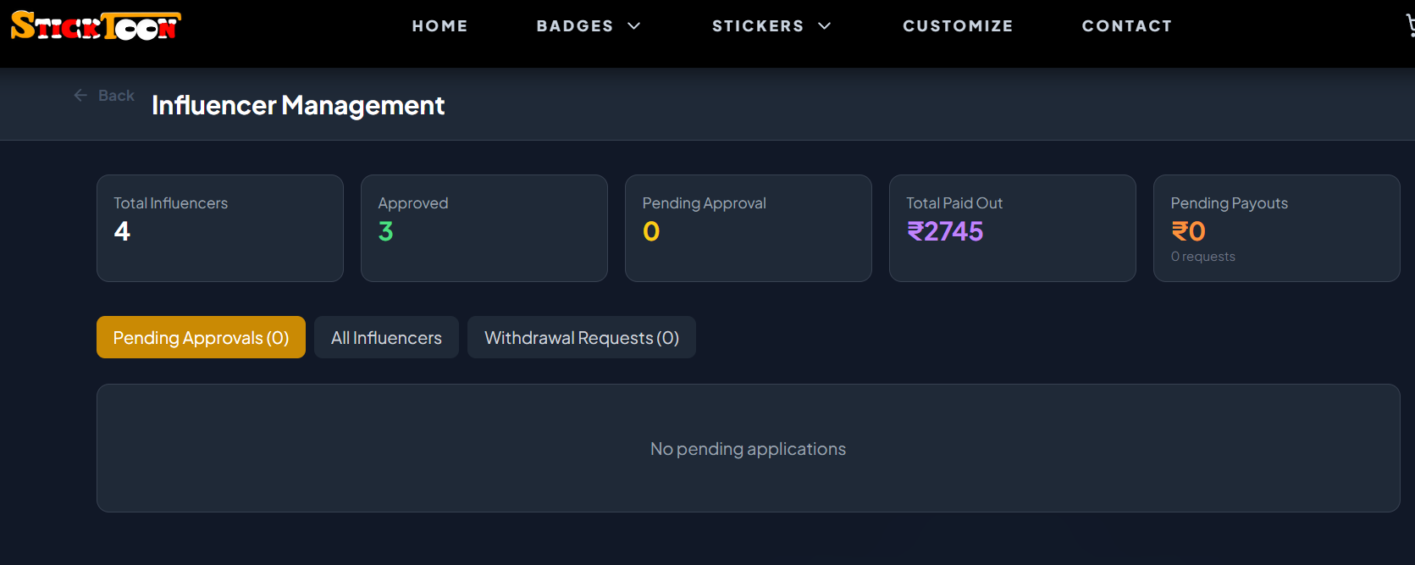
26.Add Back button everywhere in admin part atleast
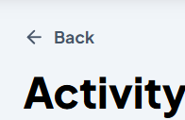
27.Tell customers magnets and badges are same but just comes with a magnet
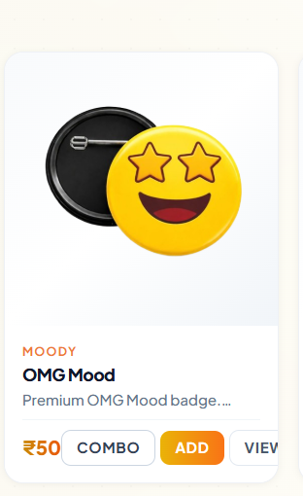
- Does not shows which address has been selected
- Haven’t logged in still proceeds to payment.
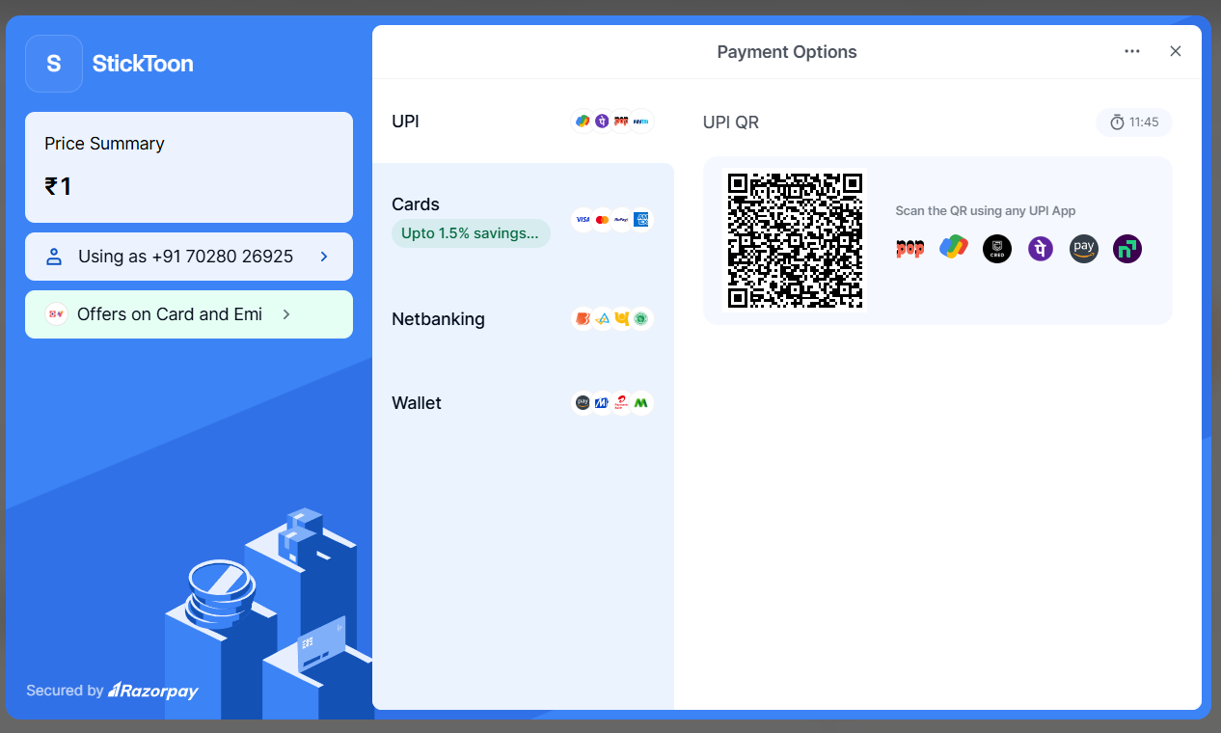
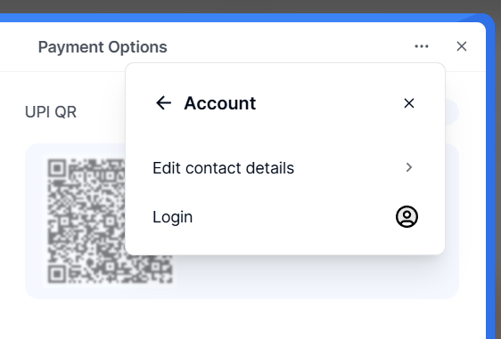
30.no option to save address.
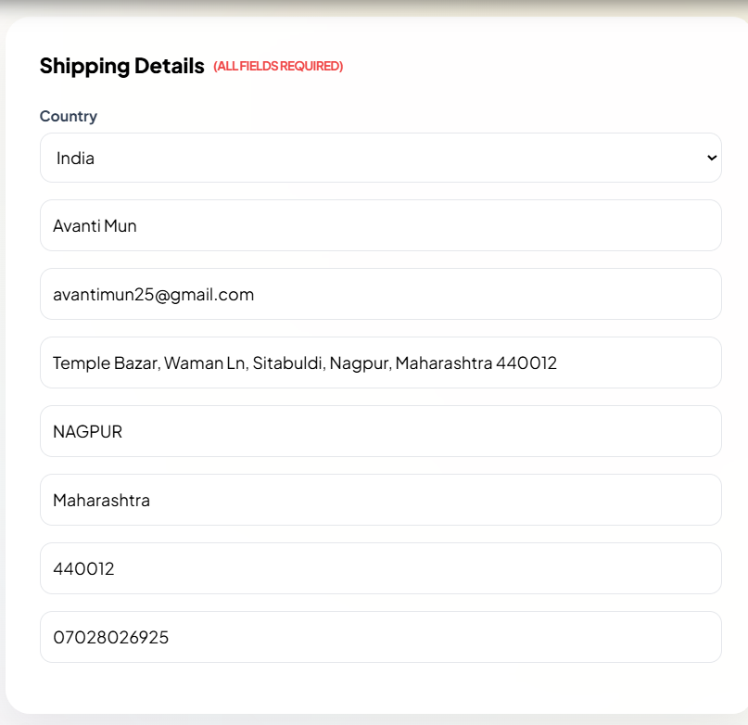
31.Does not shows address details. No way to know what address the order will be delivered to or to change or add new address.
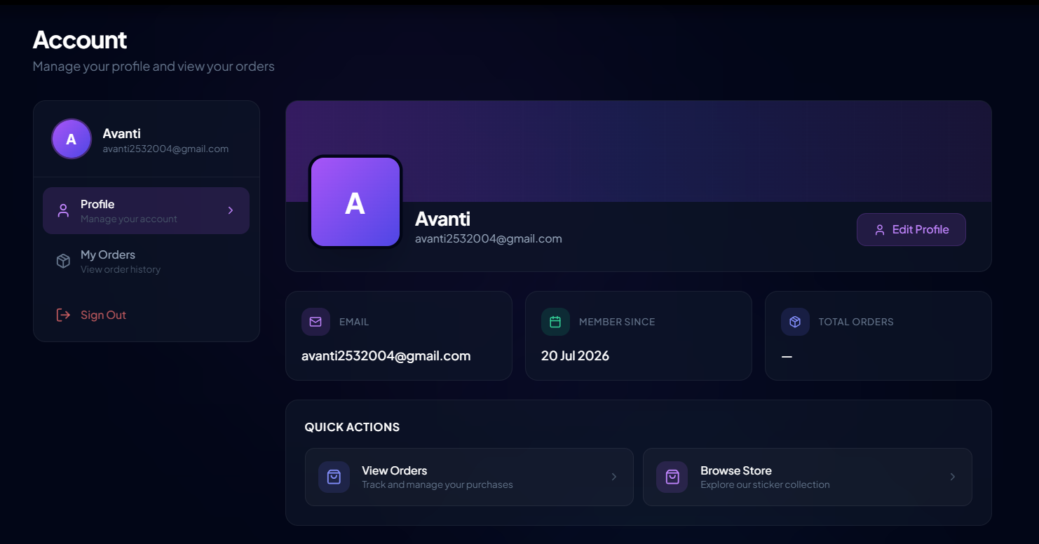
- What do I do with this? Cant complete payment cant delete this from order history
- Still shows after canceling my payment and not pacing order
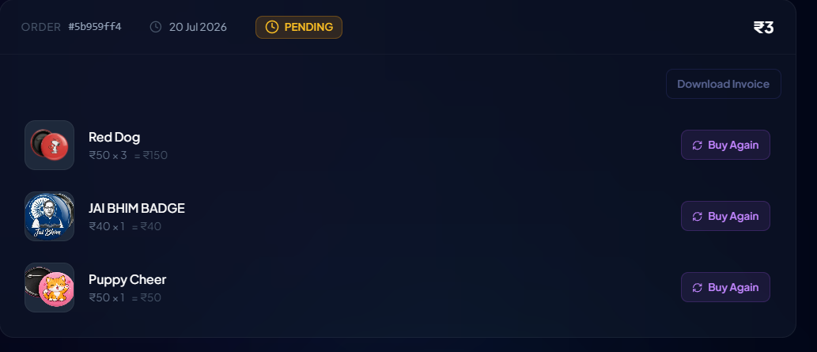
- My orders should redirect to my orders or remove it completely
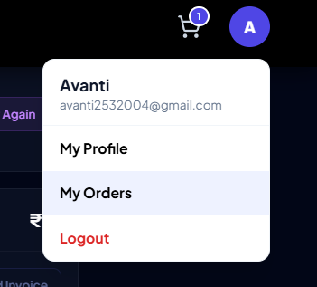
- If im already in my profile why is it giving me same options again?
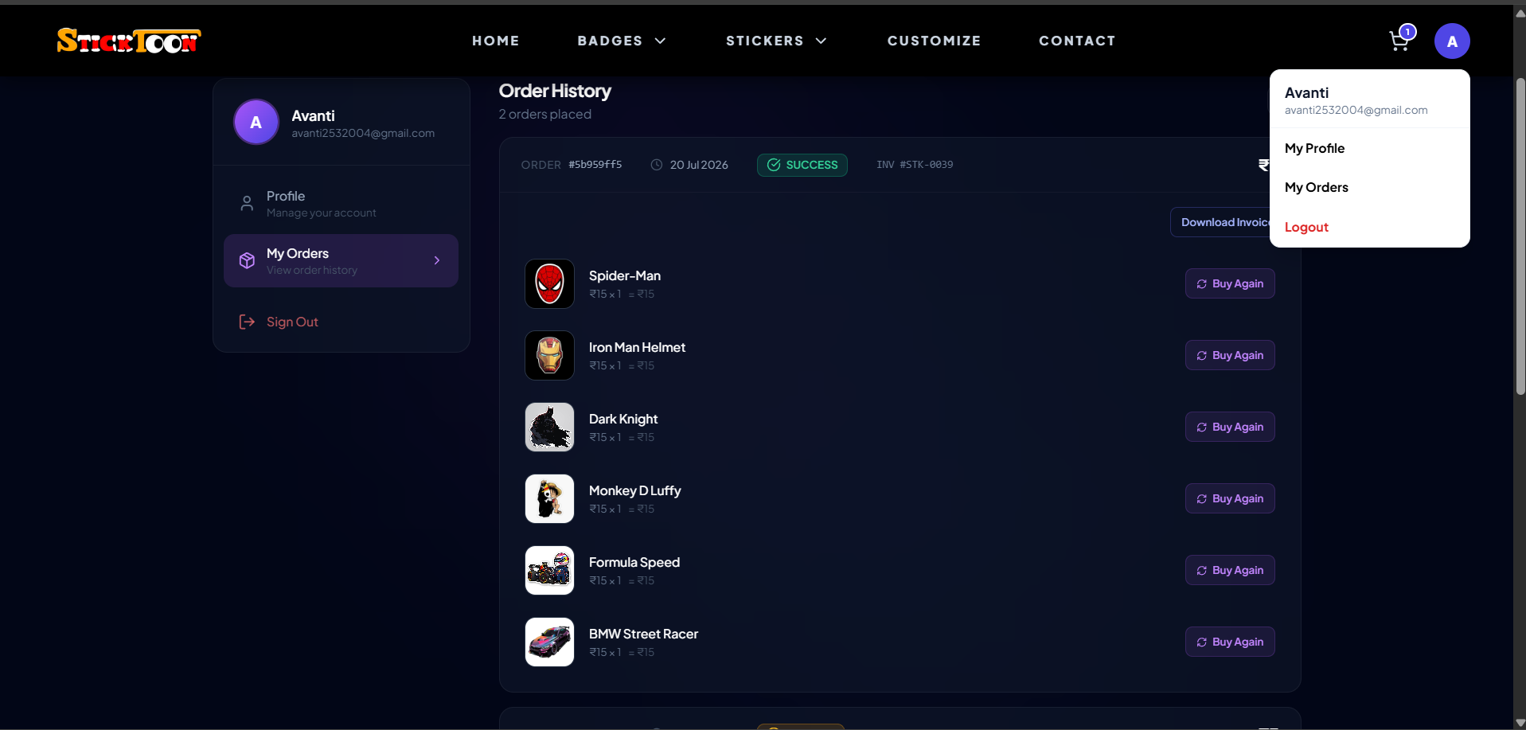
- How do I trackmy order from website?
- Shows in orders even after I canceled it
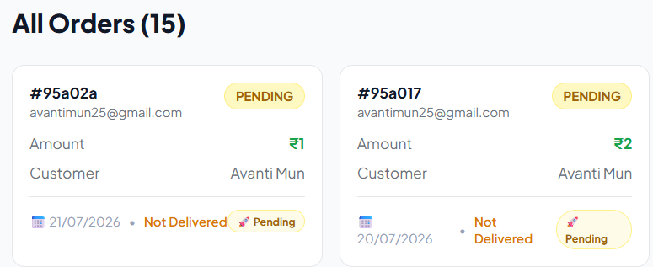
- Remove this upload photo option/ add toons to select as profilr pic
